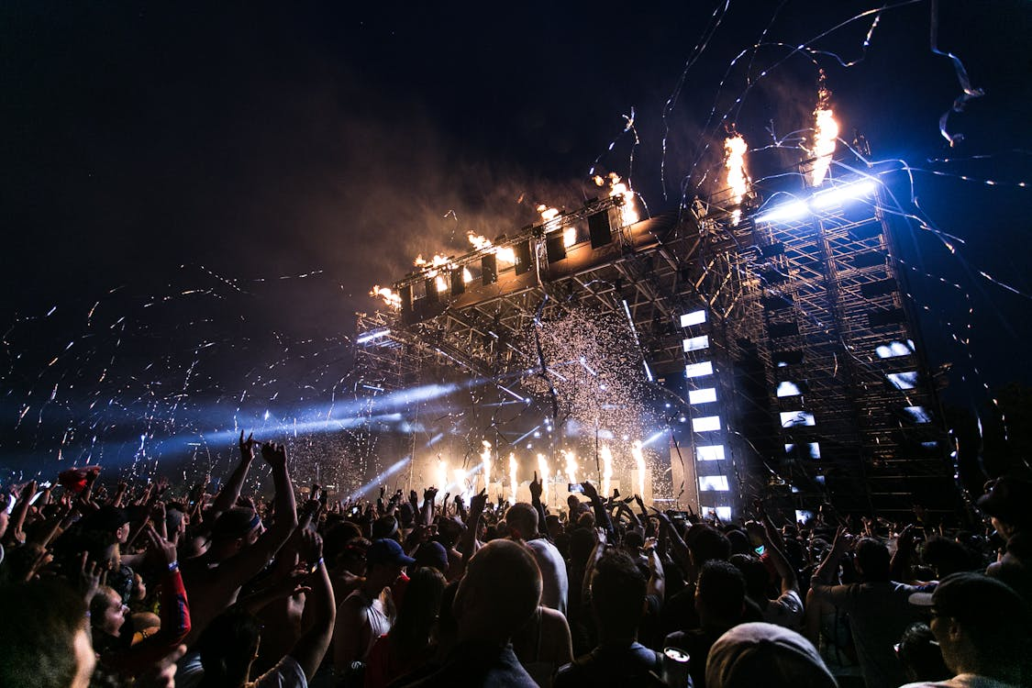
GRAND OPENING
You're Invited to Our Special Event!
WHEN:  Saturday, Nov 15  10:00 AM - 4:00 PM |  | WHERE:  [Your Store Name]  123 Main Street, Anytown

Join us for a day of celebration! We'll have live music, free samples, and exclusive discounts for our first 100 customers. Don't miss out on the fun!
- LIVE MUSIC starting at noon
- FREE SWAG BAGS for the first 100 guests
- EXCLUSIVE 25% OFF your entire purchase
Visit Our Website for More Details!

